

Project Name: Doctor’s Appointment System

Branch PG-DAC MARCH-2023

Documentation On

**“DOCTOR’S APPOINTMENT SYSTEM”**

PG-DAC MARCH-2023

**Guided By: Bakul Joshi**

Submitted By:

**Group No: 02**

* **Bagwan Abrar 230343020010**
* **Bagban Khizar 230343020009**
* **Mohd Ahsan 230343020059**
* **Amir Ahmed Shaikh 230343020086**

**Table of Contents**

**1. Introduction 4**

1.1 Document Purpose **4**

1.2 Project Background **4**

1.3 Aim & Objectives **4**

**2. Business Requirements Overview**…………………………………………………………**5**

**3.Functional Requirements** **5**

3.1 Admin Module **5**

3.2 Doctor Module **6**

3.3 Patient Module **6**

**4.** **Non-Functional Requirement………………………………………………………………6**

**5. Use Case Diagram 7**

5.1 Admin **7**

5.2 Doctor **8**

5.3 Patient **9**

**6. Database Design 10**

1 Users **10**

2 Roles **10**

3 Doctors…………………………………………………………………………………...1**0**

4 Patients…………………………………………………………………………………...**11**

5 Location **11**

6 Questions **11**

7 Appointments **11**

8 Specialties **12**

9 Schedules **12**

**7. E-R Diagram………………………………………………………………………………………13**

**8. Snapshots 14**

**9. Conclusion 27**

**List of Figures**

**Use Case Diagrams 7**

Fig 1 Admin 7

Fig 2 Doctor 8

Fig 3 Patient 9

Fig 4 ER Diagram 13

1. **Introduction:**
   1. **Document Purpose:**

This document communicates the business requirements and scope for developing Doctor’s Appointment System. The scope of this document is to define the functional and non functional requirements, business rules and other constraints requirements.

## Project Background:

In pandemic, one of the main things the whole world has understood is power of internet. Generally there is a large development of information in medical facility on a daily basis. Each manually operated administration concerning these records can result in a bunch of glitches which will also spend time, funds as well as initiatives. Additionally the medical facility can receive information after a long waiting and processing policies. This particular project will eliminate such kind of errors and long waiting process. This particular project helps to save efforts, funds and also work..

## Aim & Objectives:

The aim of this system is building a website which will reduce waiting time & crowding of patients at hospital. The main objective of the Doctor’s Appointment System is to manage the details of Doctor, patient, test, booking number. Proper management of the appointments and track all the details about the tests. Store the records systematically and securely for the further references.

1. **Business Requirements Overview:**

* Doctor’s Appointment System is the public web application used for one specific Doctor.
* There are mainly three types of user.
* Admin will be able to register a new (recruited) doctor into the system and will have access to all the details regarding appointment booking and patients taking treatment.
* Patients can search and book appointments.
* Already registered patients can view further schedule.

Doctor’s Appointment System provides such functionalities which connect doctor and patient with each other efficiently and it will reduce crowding in hospital.

# Functional Requirements Overview:

Doctor’s Appointment System consists of three modules described as below.

1. Admin Module
2. Doctor Module
3. Patient Module

# **3.1 Admin Module**

* Admin can login.
* Admin can register/approve a newly recruited doctor.
* Admin can also view the list of all the doctors and patients who are registered in the system.
* Admin can also view all details of doctors and patients.
* Admin can also view all the appointment bookings of all the doctors.
* Admin can also view most visited patient and doctor.

# **Doctor Module**

* Doctor can register.
* Doctor can login after the admin approvement.
* A Doctor can add/modify his schedule of availability.
* He can view details of patients.
* He can view the appointment schedule.

# **3.3 Patient Module**

* A Patient can register.
* Patient can login and book an appointment.
* He can login into his profile once registered.
* He can book/cancel an appointment.
* He can search doctor according to area.

1. **Non-Functional Requirement:**

* The website should use professional design, look and feel and color scheme.
* Users will have no limitations for accessing the application through Internet. The portal being an internet application, it is difficult specify exact number of visitor or users. Hence we will target the system to support between 5 and 10 thousands users on launch of phase 1.
* Being a public website, the site must follow general usability guidelines for menus, navigation, colors, links and other actions provided on the screens.
* The system should be designed in such a manner that user will be able to complete tasks in minimum number of steps.

## 5. Use-Case Diagram

**5.1 Admin:**

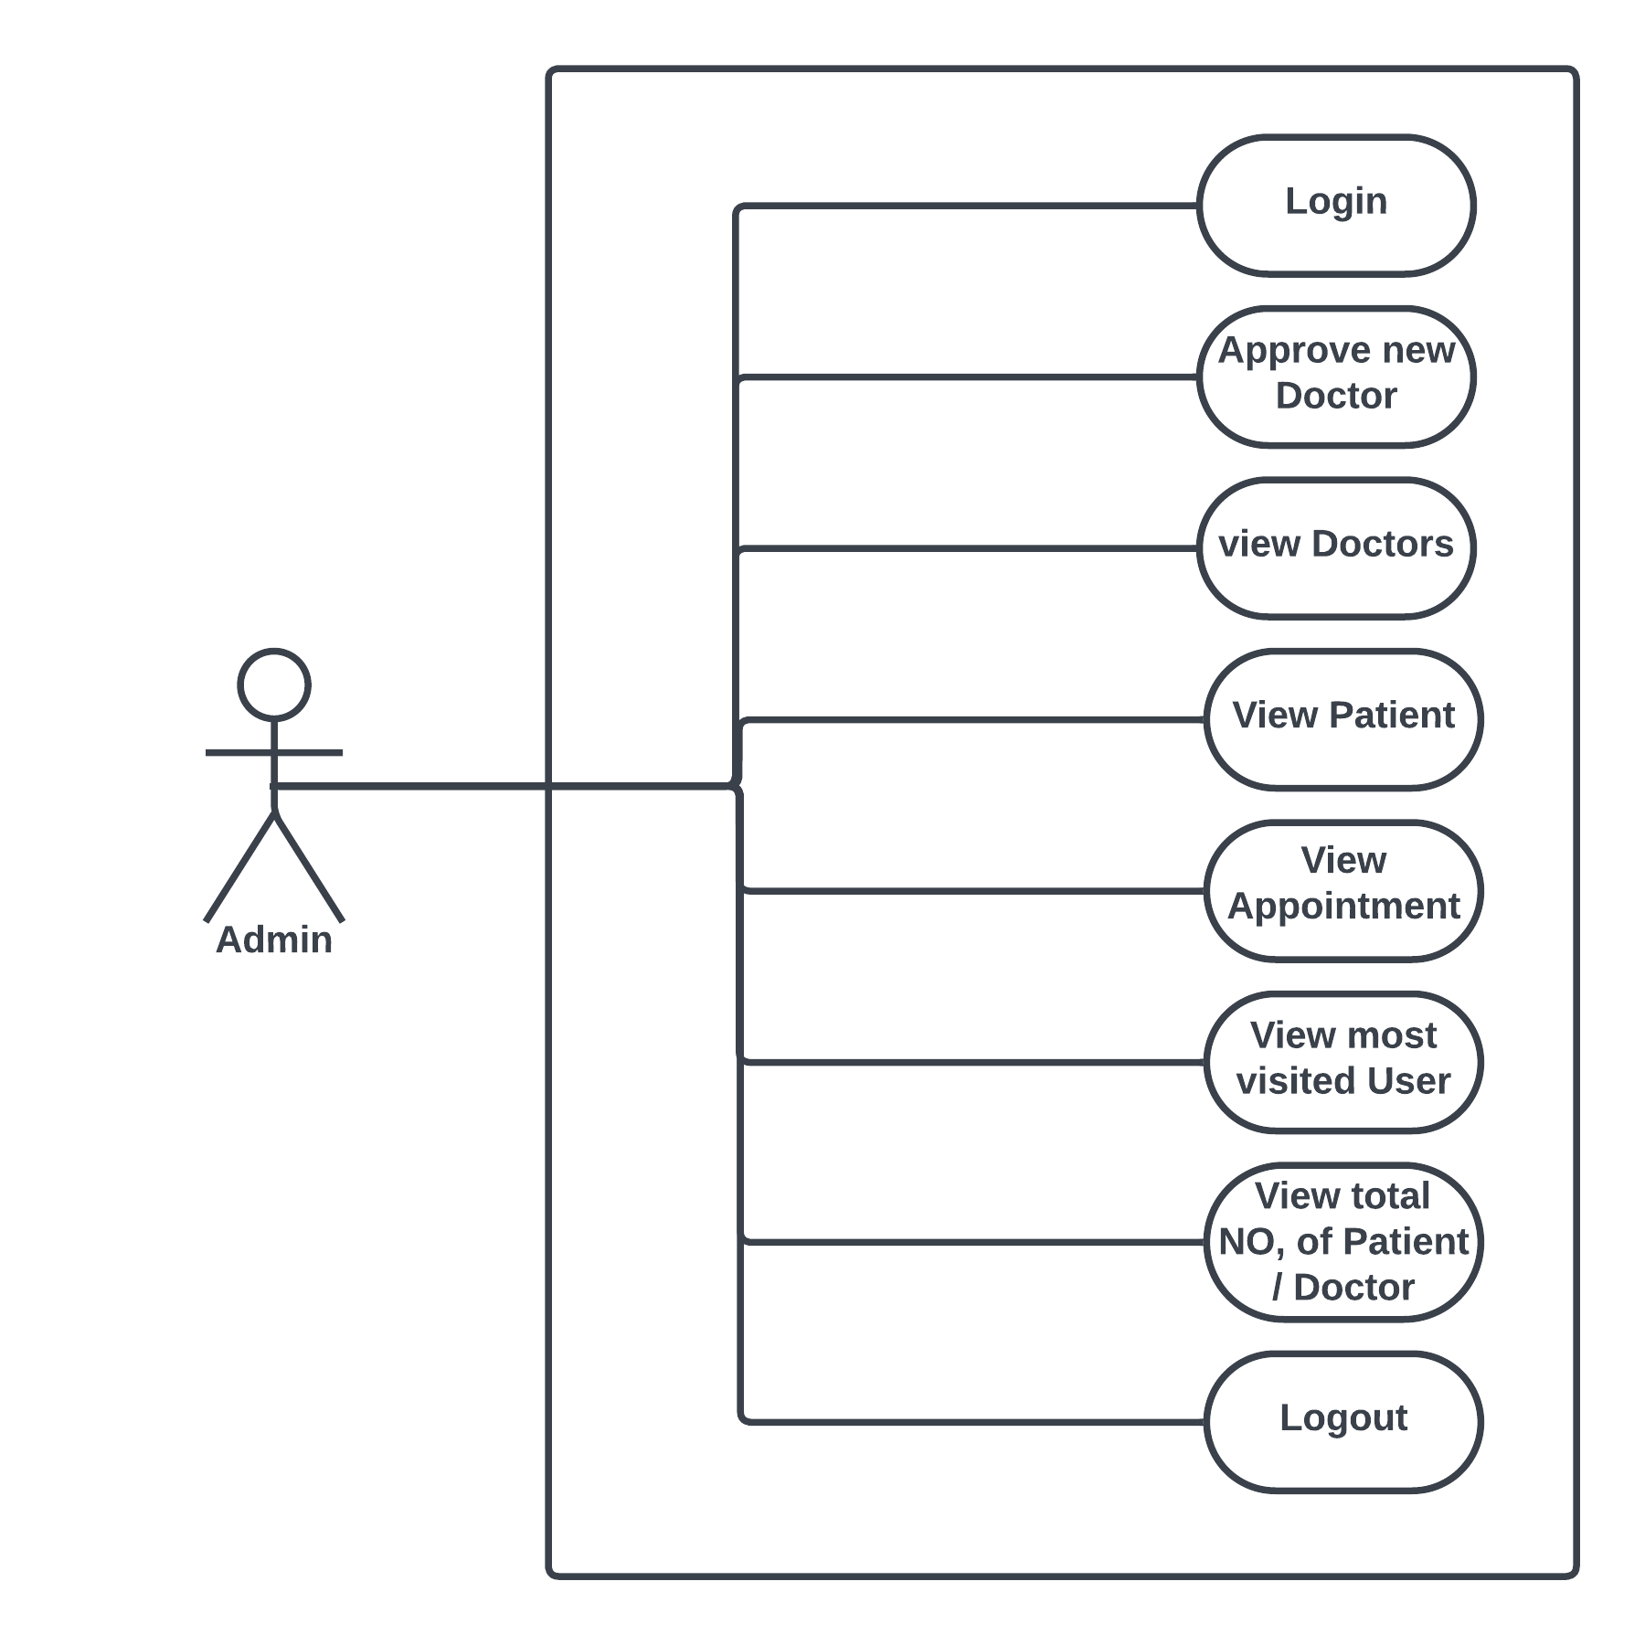

Fig. Use-Case Diagram for Admin

1. In Admin use case diagram Admin is the Actor.
2. Admin can handle following use cases:
3. Login
4. Register New Doctor
5. View Doctor Details
6. View Patient Details
7. View Appointment Details
8. Approval
9. View Most Visited User
10. View Total No. of Patient/Doctor
11. Logout

## 5.2 Doctor:

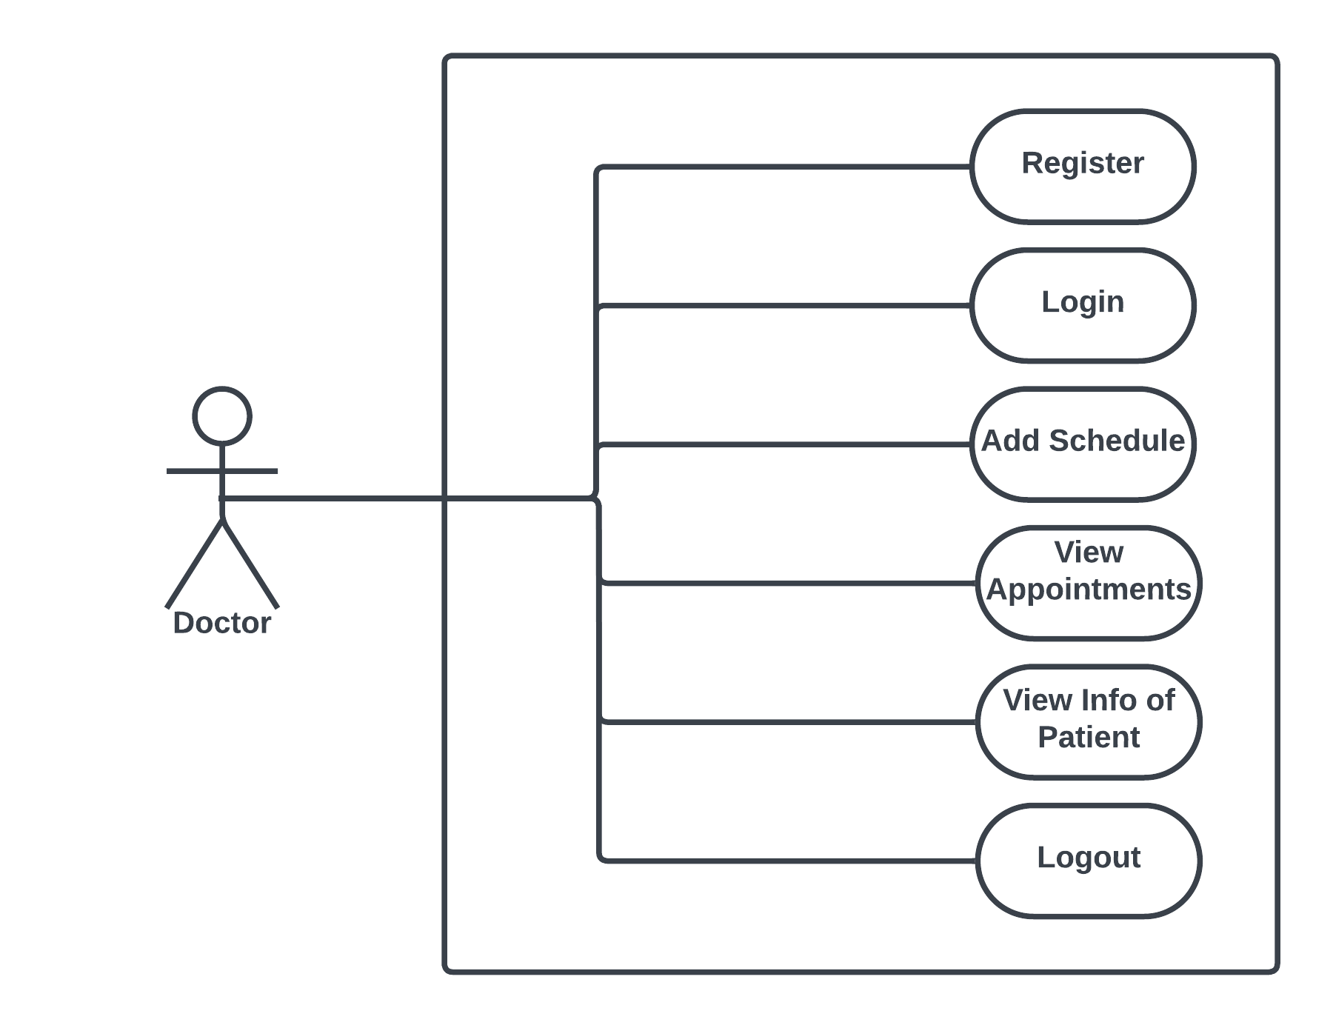

Fig. Use-Case Diagram for Doctor

1. In Doctor use case diagram Doctor is the Actor.
2. Doctor can handle following use cases:
3. Register
4. Login
5. Add Schedule
6. View Appointments
7. View Patients Information
8. Logout

**5.3 Patient:**

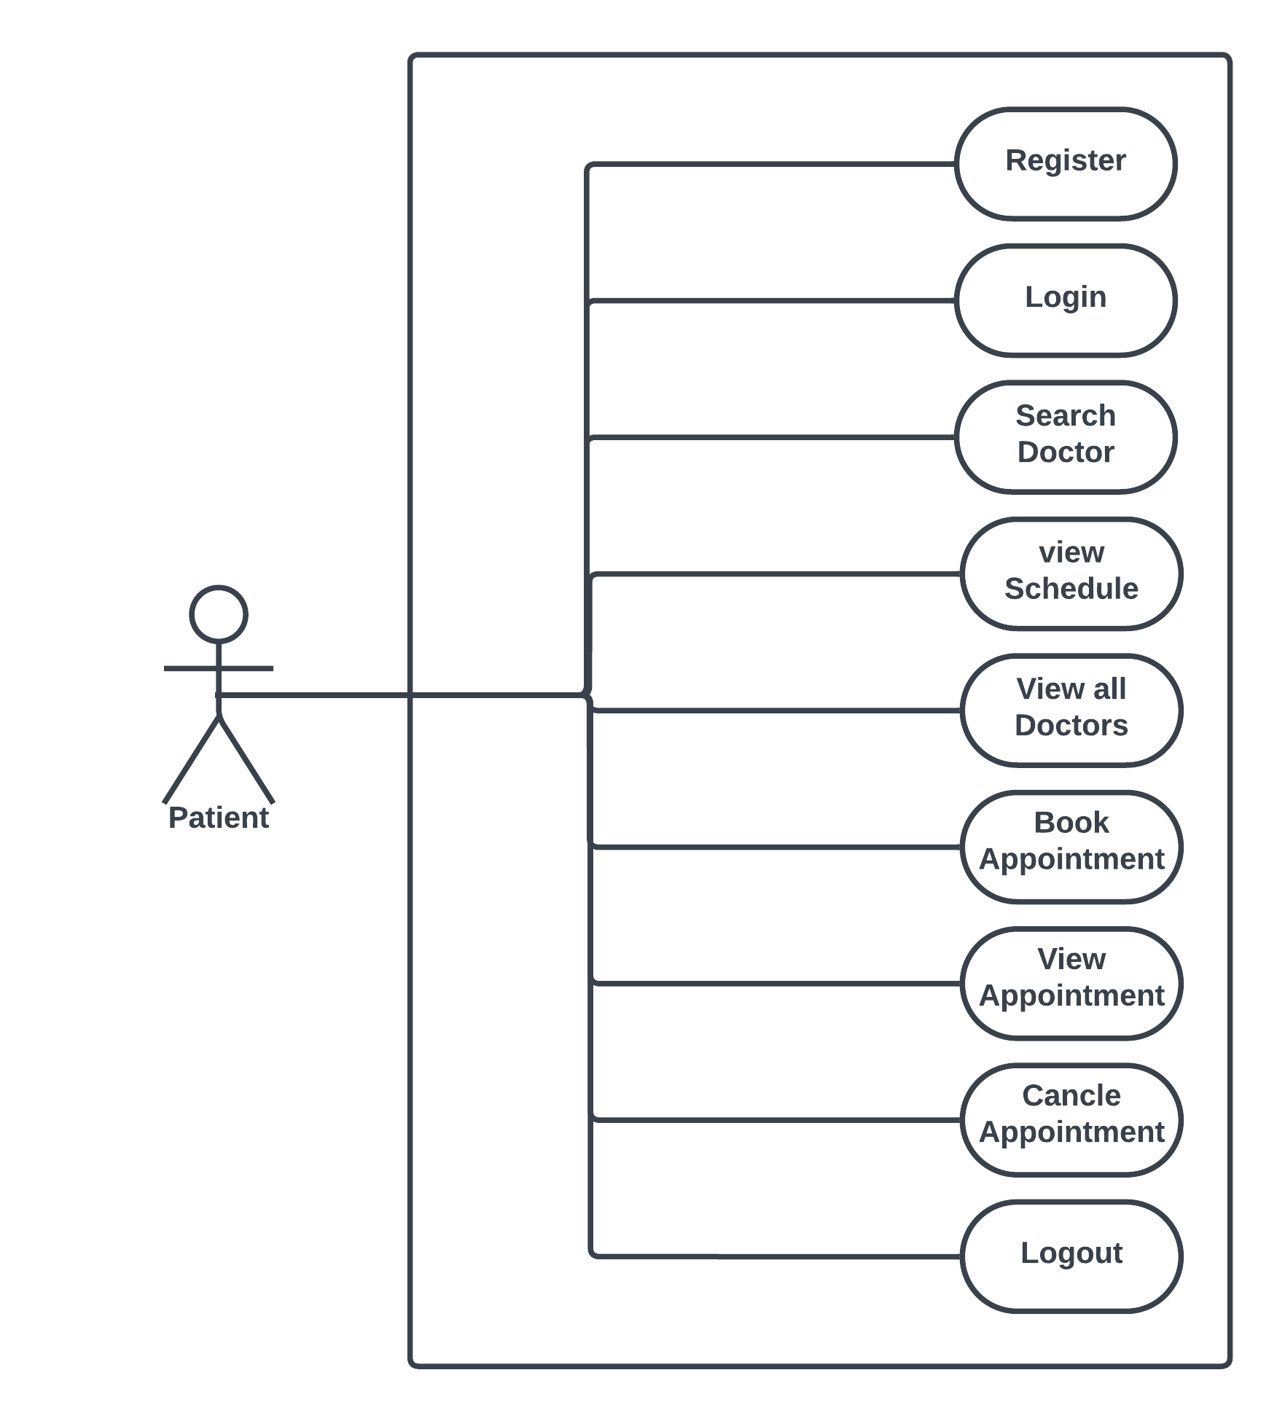

Fig. Use-Case Diagram for Patient

1. In Patient use case diagram Patient is the Actor**.**
2. Patient can handle following use cases:
3. Register
4. Login
5. Book an Appointment
6. Cancel Appointment
7. View Appointment
8. View Doctor Information
9. Search According Area
10. Logout

**6. Database Design:**

**1] users_master table**

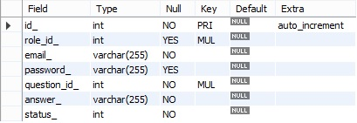

**2] role_master table**



**3] doctors_master table**

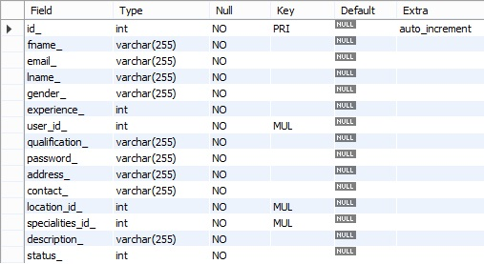

**4] patients_master table**

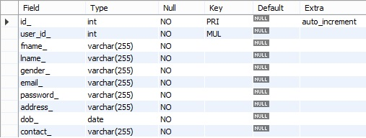

**5] address_master table**



**6] questions_master table**



**7] appointments_master table**

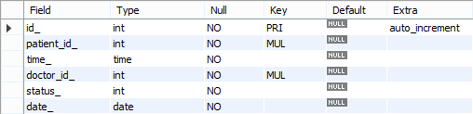

**9] schedules_master table**

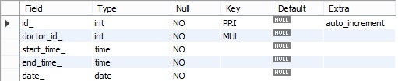

## 7. ER-Diagram:

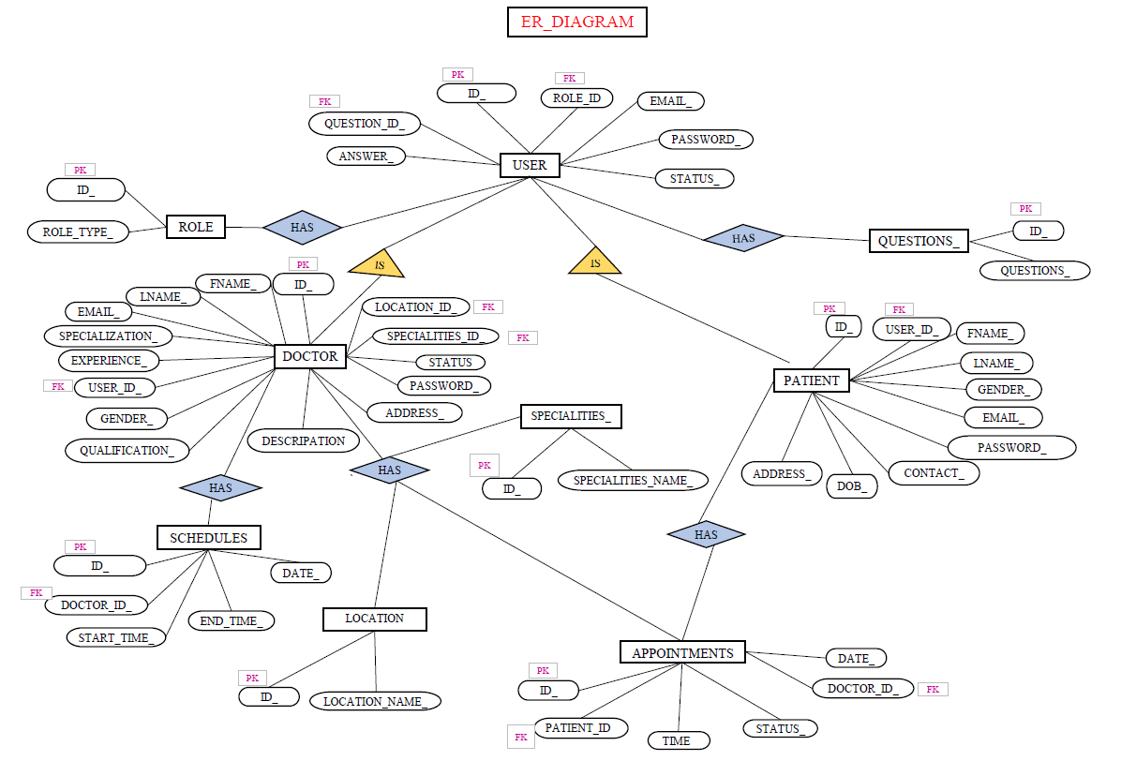

**E-R diagram shows database of Doctor’s Appointment System**

**8. Snapshots:**

**8.1 Home Page :**

Following snapshot shows the Home page for Doctor’s Appointment System

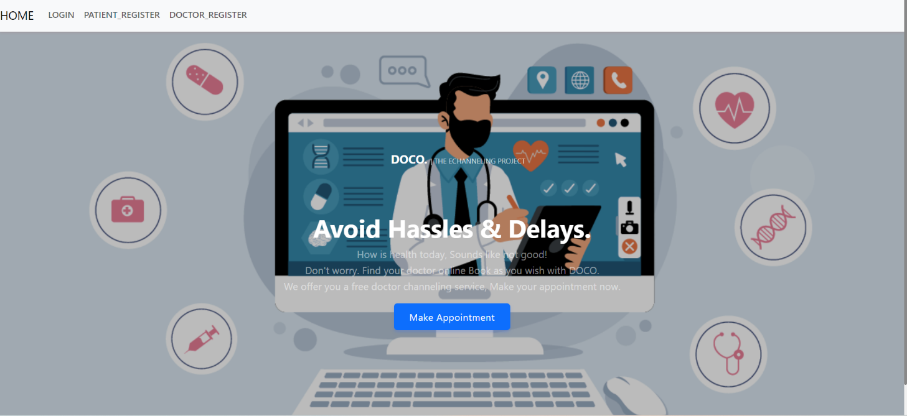

This page contains following controls

* Home
* Doctor Registration
* Patient Registration
* Login

**8.2 Doctor Registration:**

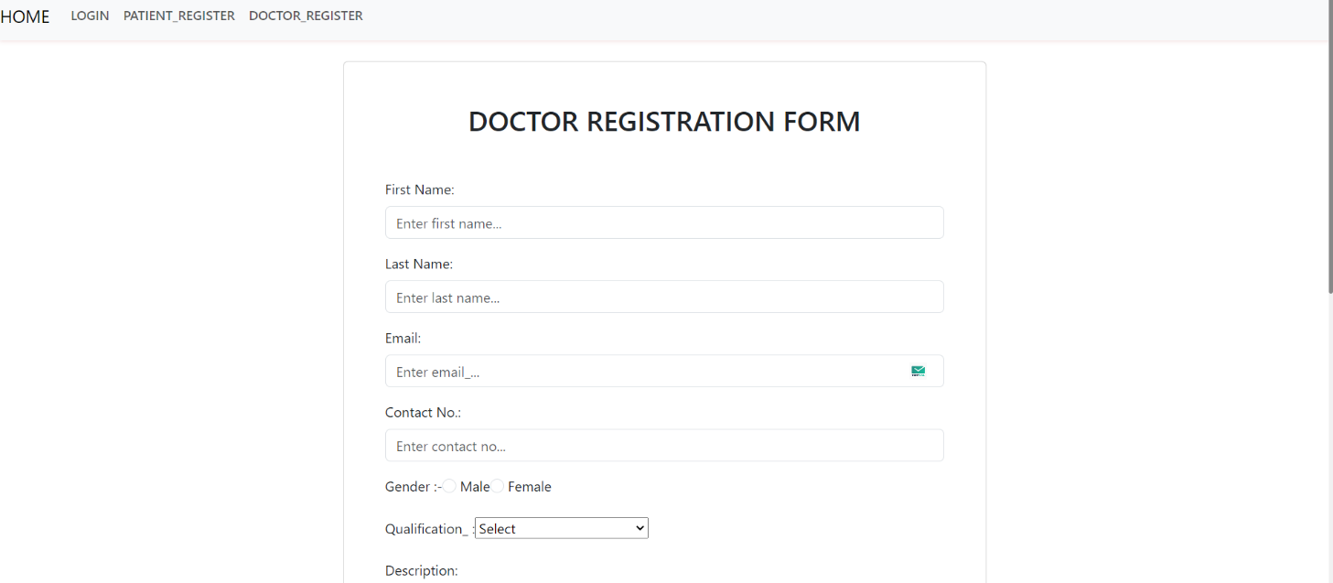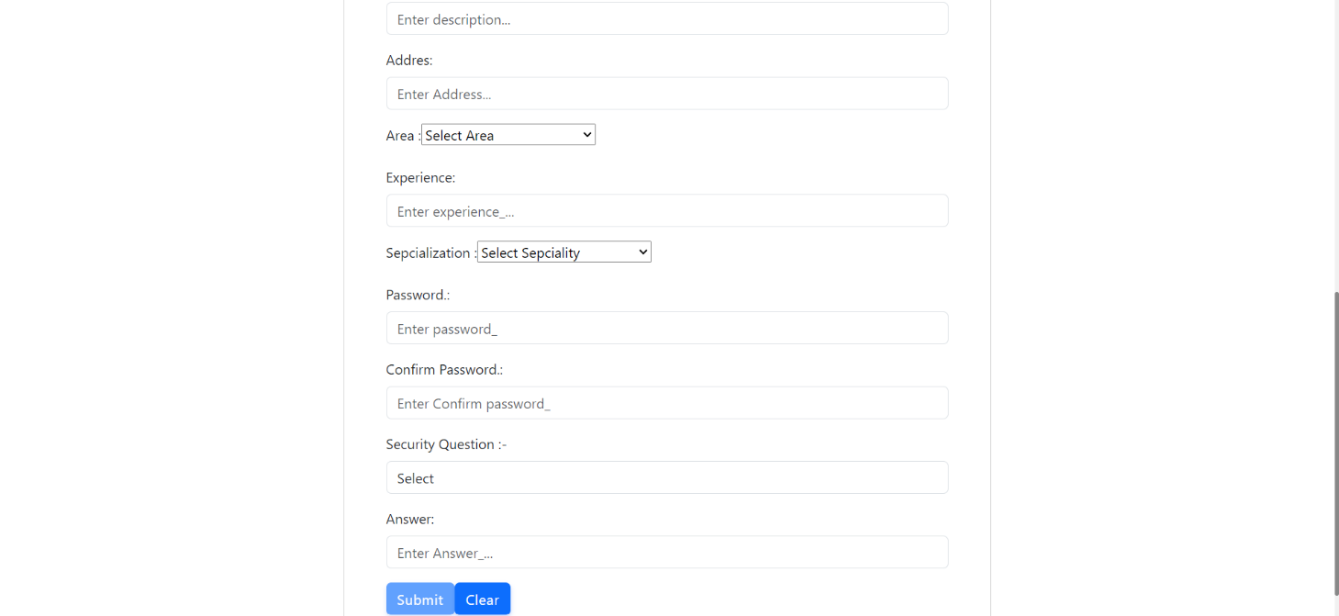

**8.3 Doctor Page :**

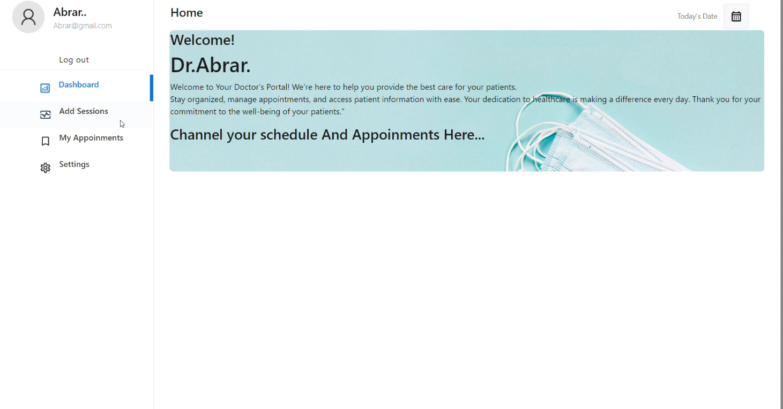

**8.4 Add Schedule:**

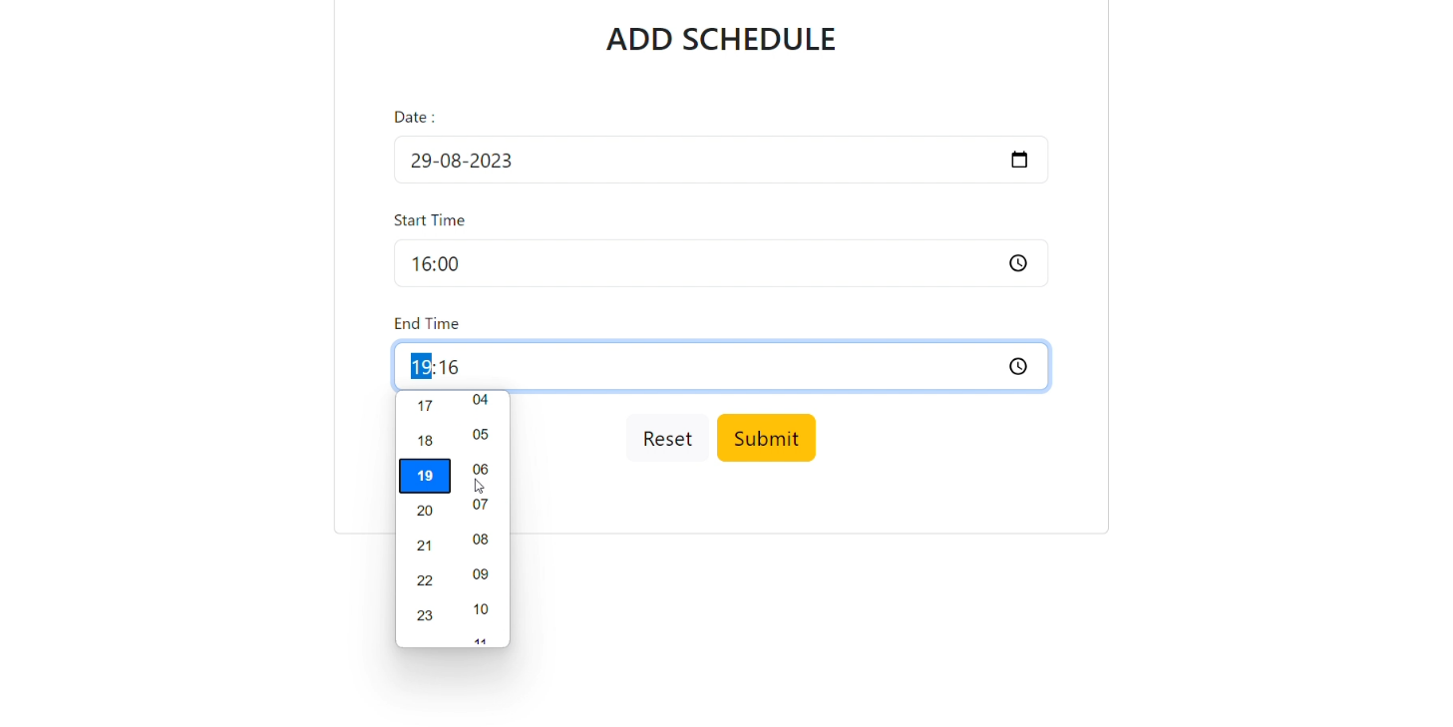

**8.5 View Appointment and cancel:**

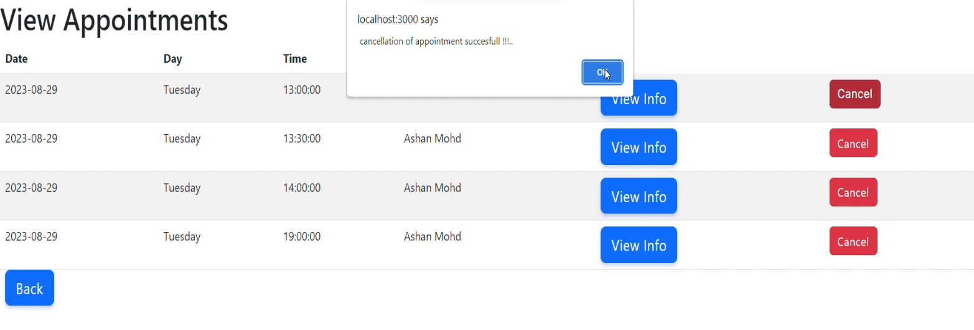

**8.6 Patient Information:**

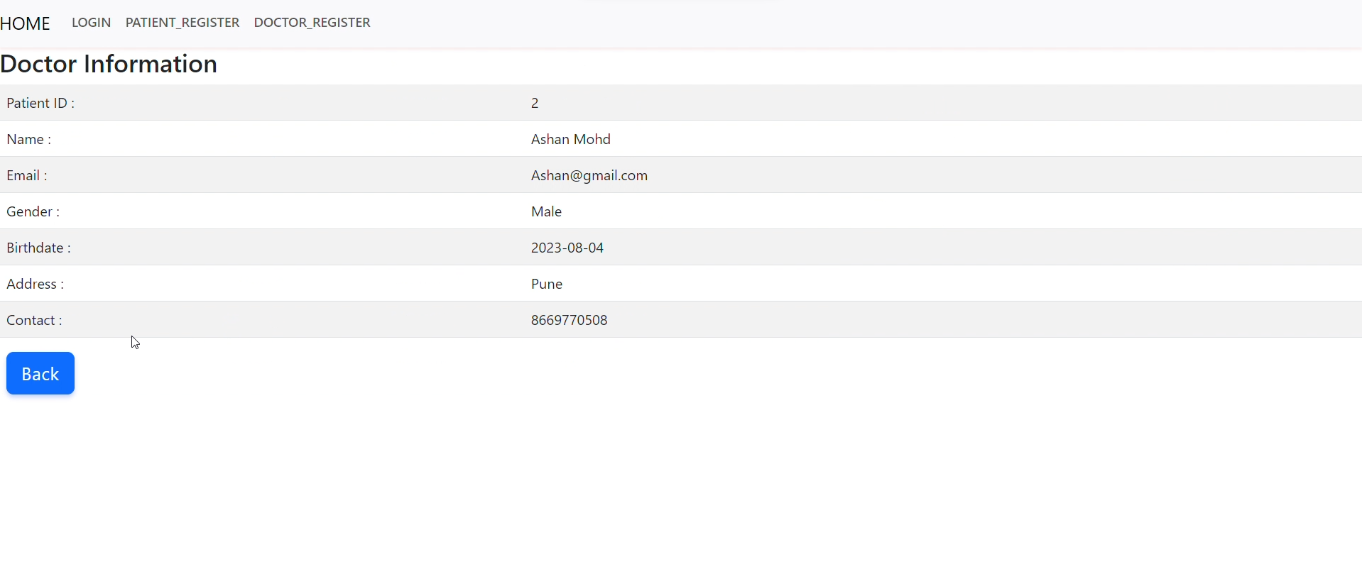

**8.7 Patient Registration Page:**

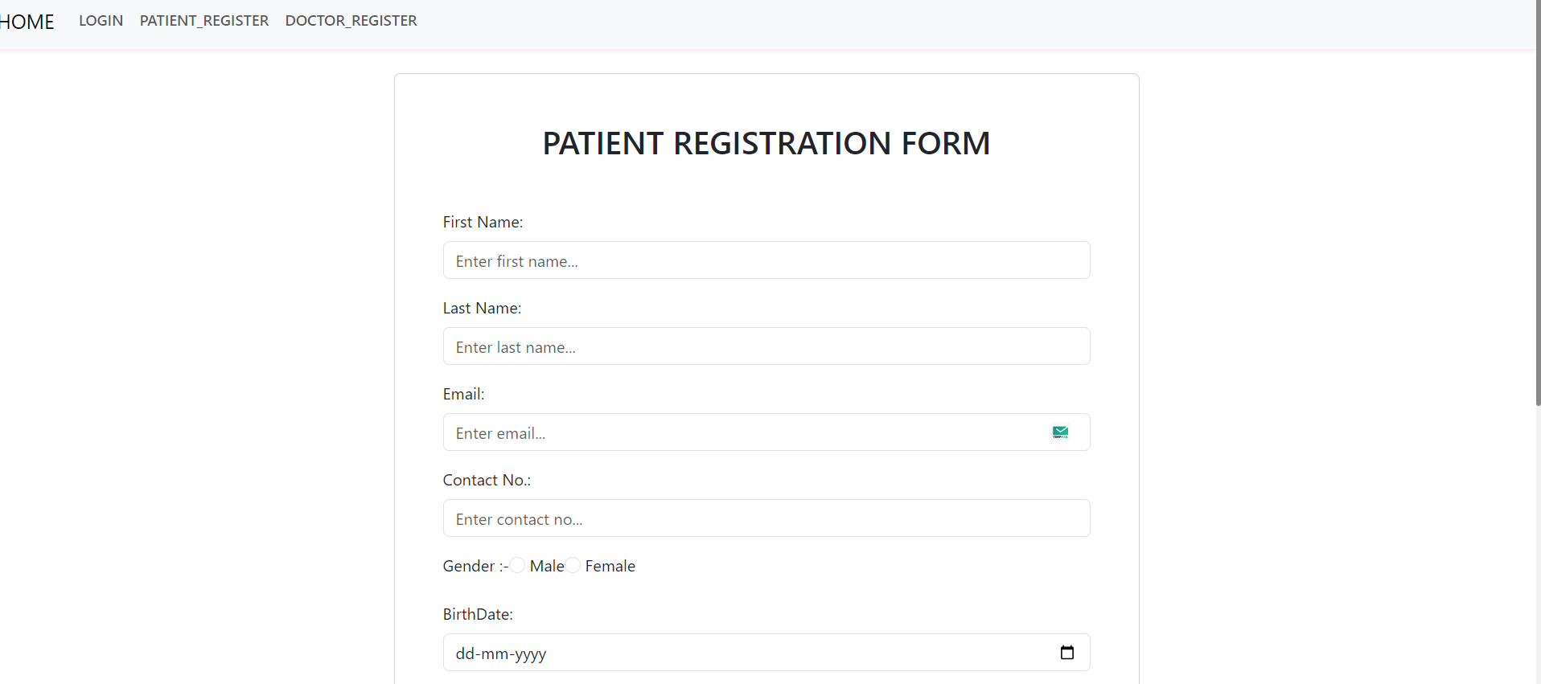

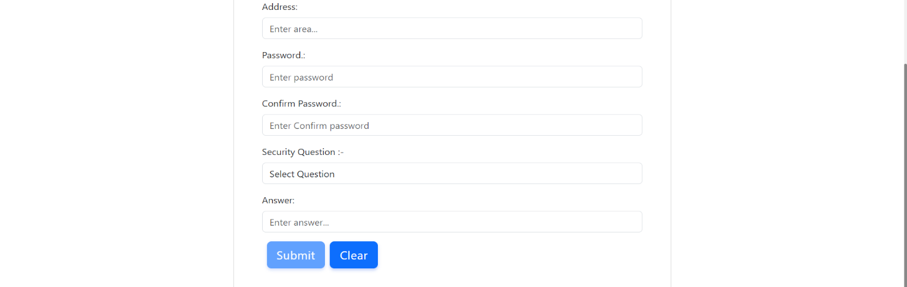

**8.8 Patient Home:**

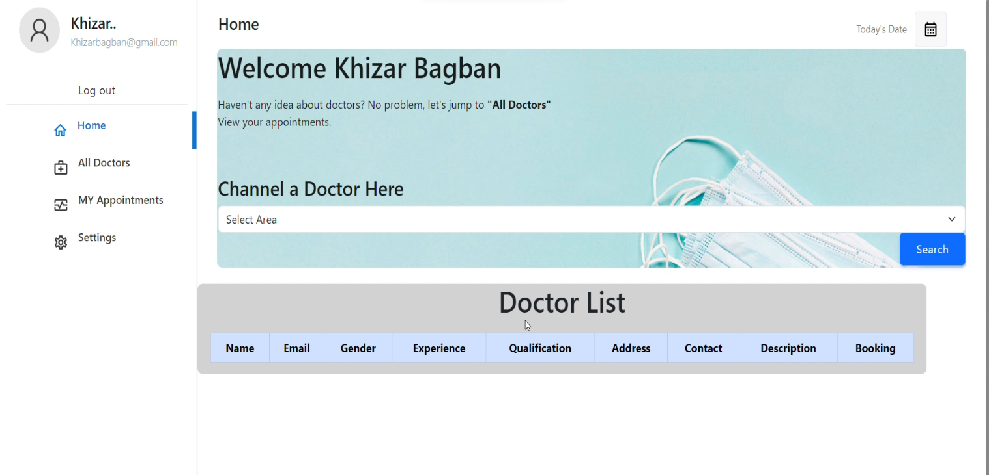

**8.9 Search Doctor:**

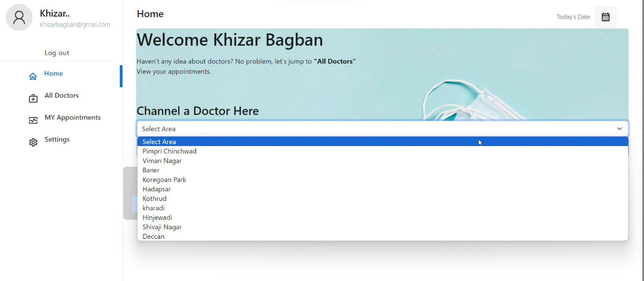

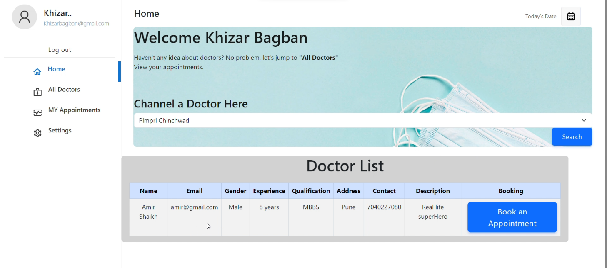

**8.10 List of Doctors:**

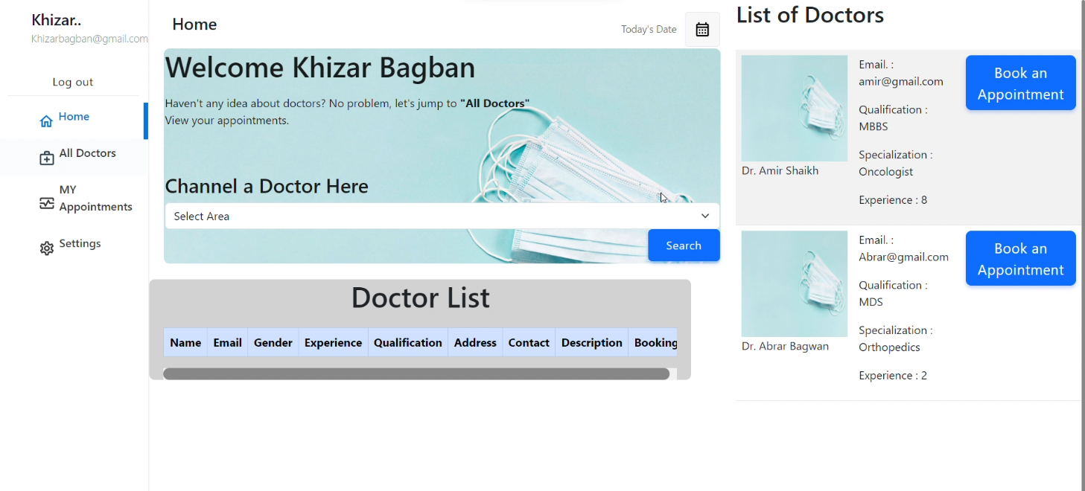

**8.11 Appointment Booking:**

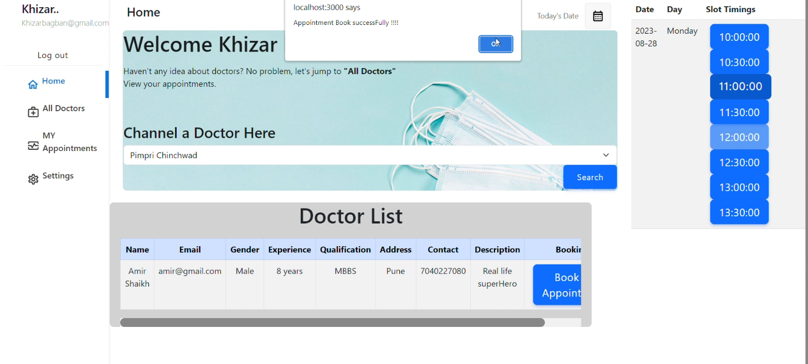

**8.12 View Appointment and Cancel:**

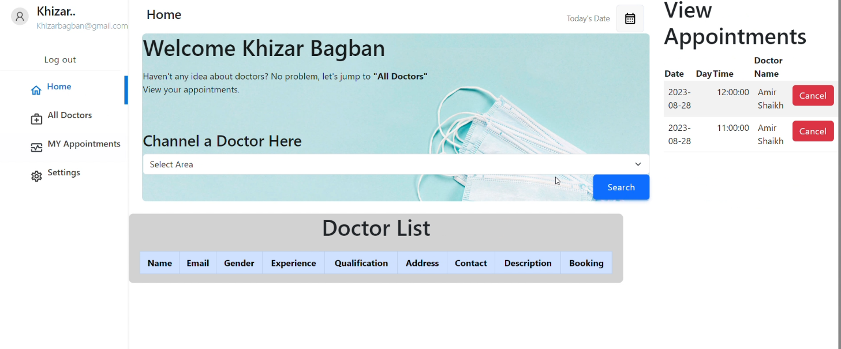

**8.13 Admin Home:**

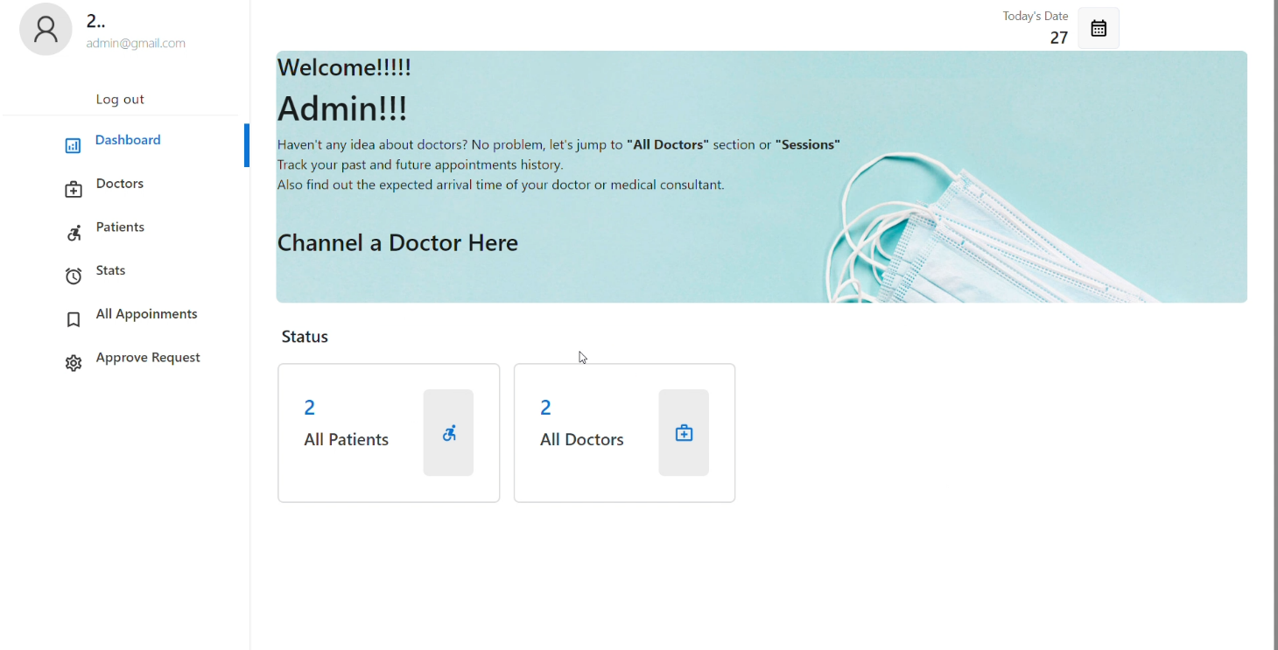

**8.14 View Appointments:**

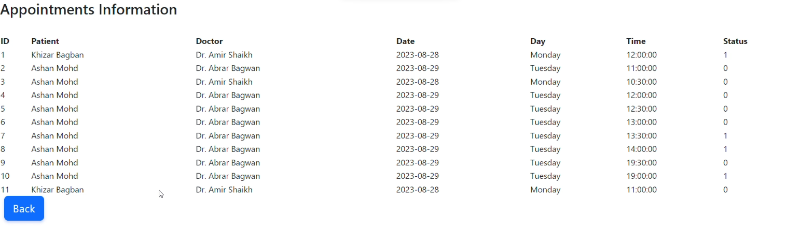

**8.15 View Doctors:**

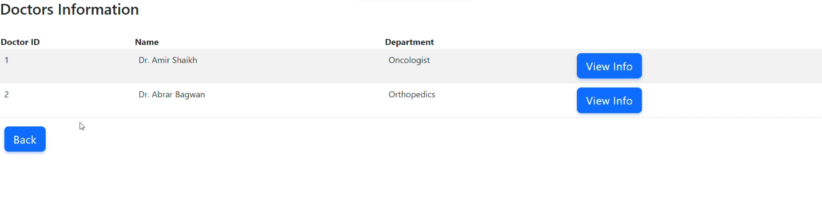

**8.16 Approve Request:**

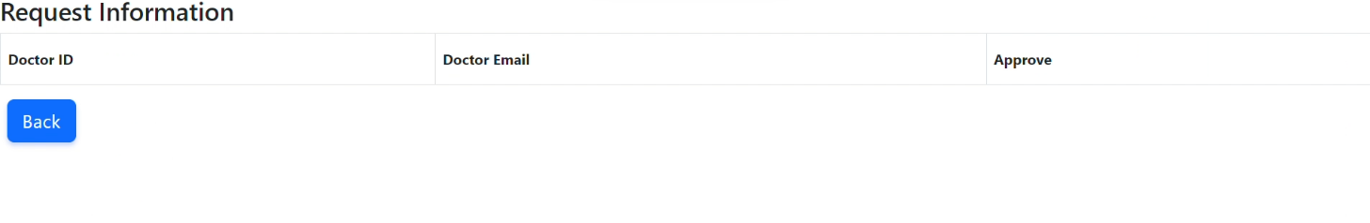

**8.17 View Patients:**

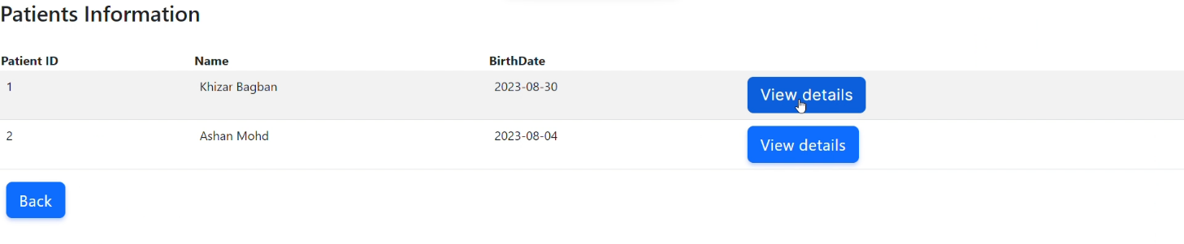

**8.18 Stats:**

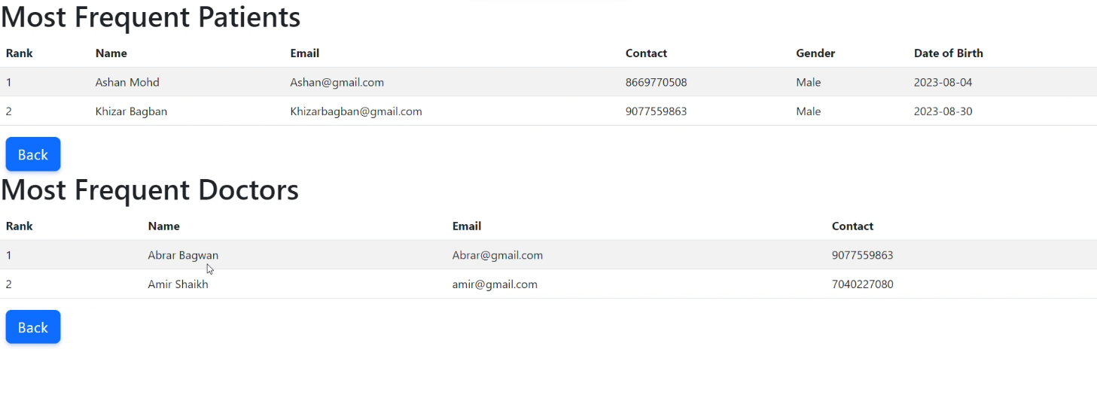

**8.19 Login:**

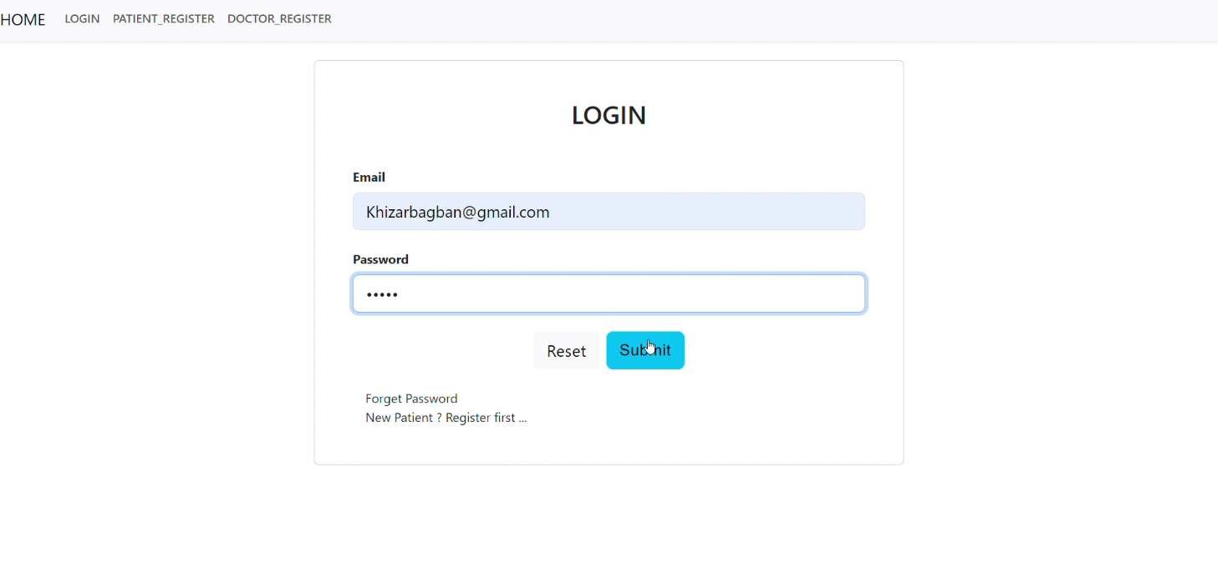

**9. CONCLUSION AND FUTURE SCOPE:**

* Doctor’s Appointment System provides better platform to get connected with doctor and patients efficiently.
* Use of this system will be specific for local clinics.
* Patient will be able to book an appointment 24 hrs. prior to the schedule.
* Doctors will be able to provide their schedule at least for one week in advance.
* Booking option will be available 24 hours, 7 days. Doctors can add their schedule at least 48 hours in advance.